
A JOINT POSITION PAPER
From Forest
Bathing to
Forest Pockets

How evidence-led forest bathing and landscape design can work together to make everyday contact with nature easier, richer and more lasting.
AUTHORED JOINTLY BY
The Forest Bathing Institute
and Petrow Harley Landscape Architects

Publication edition | 2026

CONTENTS

A shared language for a living landscape
Forest bathing starts with a simple proposition: when people are given time, permission and a thoughtful invitation, nature can become a meaningful part of how they feel, think and recover. Forest pockets take that proposition into the places where daily life already happens.

PART 1 The Why | Forest Bathing & TFBI
PART 2 The How | Forest Pockets & Petrow Harley
PART 3 What's Next | Towards a Nature Positive Future
THE INVITATION
The future of nature connection will not be found only in remote places. It will be designed into the everyday.

A NOTE ON THE COLLABORATION
This paper brings together two complementary perspectives. The Forest Bathing Institute contributes a practice grounded in peer-reviewed university research, government liaison, attention, sensory experience and human wellbeing. Petrow Harley Landscape Architects contributes a way of shaping places so that those experiences can be welcomed, supported and sustained. Together, they offer a practical bridge between the felt experience of nature and the physical conditions that make it possible.
The result is not a formula for a single type of site. It is a shared set of questions for anyone planning, designing, managing or caring for places where people and the rest of nature meet.

PART 1 / THE WHY

Forest Bathing & TFBI
The case for attention, access and a deeper relationship with the living world.
We have never been more connected digitally, yet increasingly disconnected from the natural world. For most of human history, our lives were shaped by direct contact with nature; today, particularly in cities, that relationship has grown distant.
Forest Bathing offers a simple but powerful response. Originating in Japan as shinrin-yoku, it is the practice of spending unhurried, mindful time in nature and engaging with the forest and parks through the senses. It is not about distance, destination or exertion; it is about slowing down and letting the forest become the focus of attention. The sound of leaves, the texture of bark, shifting light, the scent of the forest floor: simple experiences that offer something increasingly rare — an opportunity to pause.
Why Does Forest Bathing Matter?
The significance goes beyond feeling calmer. A growing body of research links time in nature with reduced stress, improved mood, relaxation, and beneficial changes in heart rate and blood pressure. Forests influence the autonomic nervous system, cognitive function, immune activity and psychological wellbeing. The mechanisms are complex, but the principle is simple: our bodies and minds respond to the environments we spend time in. The forest offers a unique sensory mix of natural sound, shade, phytoncides, and changing light that engages attention without demanding it.
Crucially, Forest Bathing requires no expertise. You don't need to identify trees, meditate perfectly, or even love the outdoors. It begins with something far more accessible: noticing. That accessibility is one of its greatest strengths.
From Forest Bathing to Nature Connection
We believe one of the most important outcomes is the relationship it creates between people and the natural world. When we slow down enough to notice a forest, perception shifts: a tree becomes more than shade, birds more than background noise, a woodland floor a complex living system. This matters because environmental challenges biodiversity loss, climate change, habitat degradation cannot be solved by technology and policy alone. They require people to care. Meaningful experiences of nature build that connection, making people more aware of its value and more motivated to protect it. Forest Bathing can thus contribute to something larger than individual wellbeing: a culture in which people see themselves as part of nature, not separate from it.
A USEFUL DISTINCTION
A forest bathing experience does not use nature as a backdrop to another activity, such as walking or running. It helps people notice the subtle detail and inherent beauty which nourishes the nervous system and was designed as the perfect antidote to Technostress (stress caused by over use of technology.

The Work of The Forest Bathing Institute
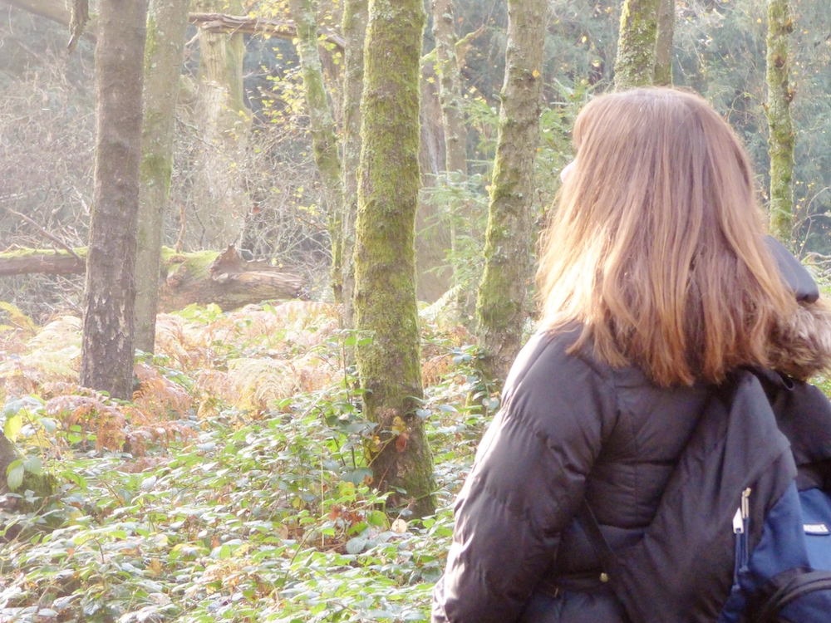
Forest bathing experience
© Photograph by The Forest Bathing Institute

TFBI was established to develop, research and promote Forest Bathing as a credible, accessible, evidence-informed approach to health and wellbeing. Our work sits at the intersection of nature, health, research and education, collaborating with universities, researchers, landowners, environmental organisations, healthcare professionals, the national press and public bodies. We support research into the physiological and psychological effects of Forest Bathing, and we train practitioners so the practice is delivered responsibly with a clear understanding of both its benefits and its limits. This matters because Forest Bathing should not become another wellness trend. Its value lies in the quality of the experience, the integrity of the practice, and the relationship between people and the natural environment.

Making Nature Connection More Accessible
The challenge now is making meaningful experiences of nature available to more people. A session in beautiful woodland can be transformative, but not everyone has access to a forest; people may live in cities, have limited mobility, lack transport, financial resources or lack the confidence to enter unfamiliar natural environments. So, we must think beyond the forest itself. Could a hospital garden become a place of restoration? Could a workplace offer nature connection during the working day? Could a housing development incorporate biodiverse spaces for people and wildlife? Could a small urban landscape offer calm in a busy city?
Forest Bathing reminds us why nature matters. The next challenge is bringing those principles into the everyday environments where millions of people live.

The central question is simple: what would help someone feel more able to notice, value and care for the living world around them while enjoying the restorative benefits of the environment?

PART 2 / THE HOW

Forest Pockets & Petrow Harley Landscape Architects
Designing small, legible moments of nature connection into the places people already use.

A forest pocket is not a miniature forest
A forest pocket is a compact, carefully considered place that makes nature more present in everyday life. It might sit beside a workplace, within a neighbourhood, at the edge of a learning environment or along a civic route. Its scale can be modest. Its ambition is not.
The point is not to reproduce a woodland in miniature. The point is to create conditions for a different kind of encounter: a moment of arrival, a shift in pace, a glimpse of seasonal change, a place where the senses can settle, and attention can widen. A forest pocket works when it feels both specific and open-ended, designed enough to welcome people but alive enough to remain surprising.

What good design holds
- A threshold: a clear transition from ordinary movement into a slower, more attentive mode.
- Layered experience: something to notice close at hand, at eye level and beyond, with variation in texture, height, sound and light.
- Legibility without prescription: cues that help people understand how to use the space, without telling them what they must feel.
- Seasonal change: planting and management that make time visible, so the place keeps offering a reason to return.
- Stewardship: access, materials and maintenance that protect the ecology which gives the experience its meaning.

The role of Petrow Harley
Petrow Harley Landscape Architects brings the spatial and environmental intelligence needed to translate these principles into place. Landscape architecture can choreograph arrival and movement, shape enclosure and prospect, select materials and planting, and balance delight with durability. It can also make the less visible work of stewardship legible: where water goes, how habitats are protected, and how a place changes over time.
This is where the two disciplines meet. Forest bathing asks what kind of attention a place can invite. Landscape design asks what physical, ecological and social conditions can hold that invitation. The best forest pockets are therefore not decorative add-ons. They are small pieces of living infrastructure, with a clear purpose and a long view.
DESIGN TEST
If the space looks complete on day one but has nothing new to reveal in season three, it has been designed as an object rather than as a relationship.

A SHARED SEQUENCE

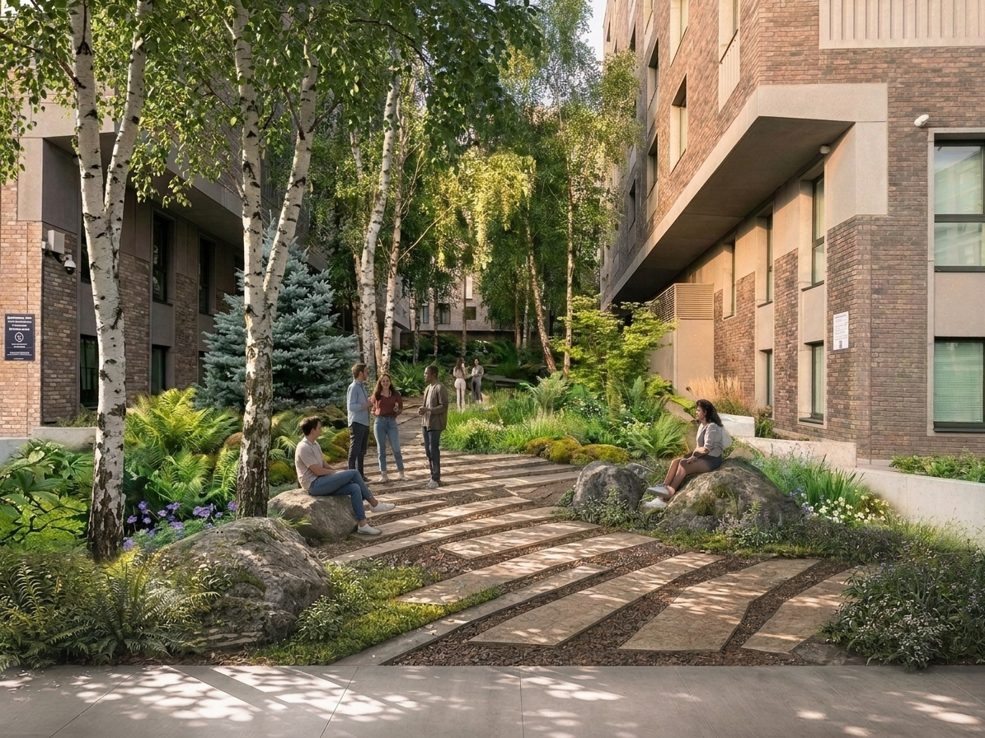
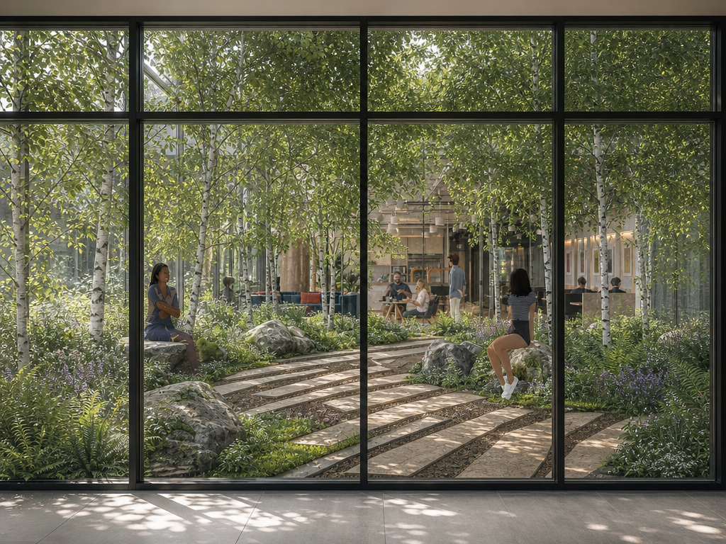
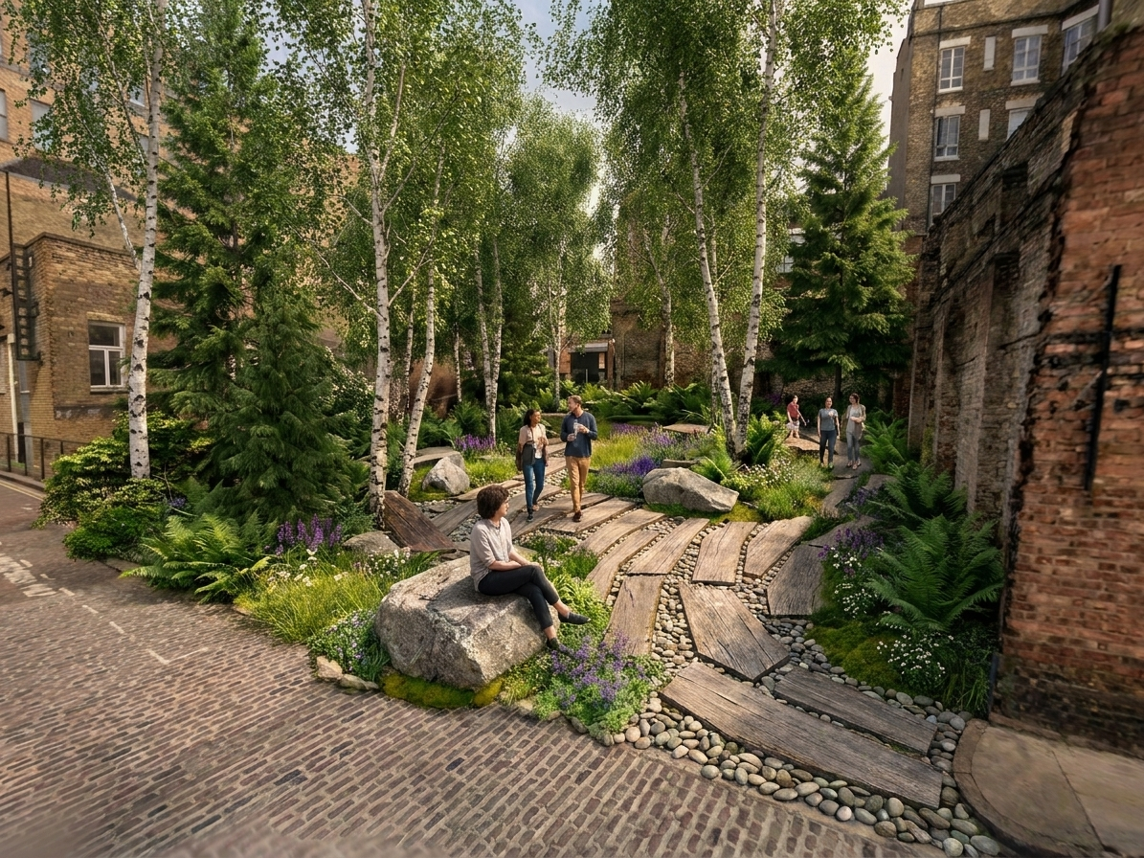
Examples of Forest Pocket Designs
© Design and visualisation by Petrow Harley Landscape Architects

From arrival to return
A forest pocket can be understood as a sequence rather than a single feature. The sequence below is not a prescriptive layout. It is a way to test whether a proposal supports the emotional and sensory arc of a forest bathing invitation.
MOMENT | INTENT | DESIGN CUES
Arrival | Help the body register a change of pace. | A visible threshold, a pause point, a change in surface or planting character.
Orientation | Offer enough information to create confidence and choice. | Clear routes, comfortable edges, accessible options and a light touch of interpretation.
Invitation | Open the senses without requiring a particular outcome. | Sound and visibility: let the gaze travel and identify places to look closely and recognise details such as contrasts in texture, height.
Linger | Make stillness feel supported rather than exposed. | Informal sitting, shade and shelter, good sightlines, and enough room for different ways of being together or alone.
Return | Leave with a sense of continuity and a reason to notice again. | Seasonal markers, changing planting, stewardship cues and a route back into everyday life.

Measure what matters
A forest pocket should be evaluated by more than its footprint, planting count or visual impact. Those measures have their place, but they do not tell the whole story. A fuller evaluation asks whether people can find the place, whether they feel welcome there, whether they stay, what they notice, and whether the landscape is becoming more ecologically capable over time.
The evidence can be both qualitative, quantitative and practical: observations of use, conversations with people who experience the site differently, university-led physiological assessments and mental health assessments, seasonal ecological checks, maintenance learning and simple reflections on what the space makes possible. The aim is not to turn an encounter with nature into a transaction. It is to learn whether the design is doing its quiet work, building on the approach pioneered by the Japanese government.

PART 3 / WHAT'S NEXT

Towards a Nature Positive Future
Moving from isolated interventions to a culture of everyday care.

From sites to systems
One forest pocket can change the feel of a place. A network of forest pockets can change what a community expects from its public realm, its workplaces, its learning environments and its routes through the day. The opportunity is not simply to add more green space. It is to make nature connection part of how places are planned, used, managed and valued.
That shift requires collaboration across disciplines and across time. A guide may understand how an invitation lands with different people. A landscape architect may understand how a planting palette matures and how it can physically integrate into the built form. Clients, communities, ecologists, maintenance teams and users each hold part of the picture. A nature-positive future is built when those forms of knowledge are brought into the same conversation.
A WIDER AMBITION
Design for the first encounter, then manage for the hundredth.

A potential practical pathway
- Start with listening. Understand the rhythms of the site, the people who use it, the people who do not yet use it, and the living systems already present.
- Define the invitation. Decide what kind of attention, ease and connection the place should make possible, while leaving room for many different experiences.
- Design for change. Select structures, planting, and management approaches that can adapt, mature and become more ecologically valuable over time.
- Learn in public. Share what is working, what is not and what the landscape is teaching. Use feedback to improve the place rather than defend a finished scheme.
- Connect the dots. Treat each forest pocket as part of a wider network of habitat, movement, health, learning and belonging.

FIVE COMMITMENTS

The work ahead
- Make access to meaningful nature more ordinary, not more exclusive.
- Treat sensory experience and ecological function as mutually reinforcing, not competing priorities.
- Design with humility. Allow a place to remain alive and evolve naturally, giving the landscape room to breathe, adapt and rebalance. By creating space for biodiversity to flourish, we also create places that continually change and surprise, offering visitors something new to discover each time they return.
- Build stewardship into the brief, the budget and the everyday life of the site.
- Measure success through relationship: what people notice, how they care, and what the landscape can continue to give.

A shared conclusion
Forest bathing and landscape architecture begin from different starting points, but they are drawn towards the same horizon. Both ask us to pay attention to the conditions that allow all life to flourish. Both understand that a place is more than its appearance. Both recognise that care is not an afterthought but a design material.
Forest pockets offer a tangible next step. They bring the invitation of forest bathing into the grain of everyday life, and they give landscape design a human-scale way to demonstrate what nature-positive thinking can feel like. They can be small enough to start now, yet foundational enough to contribute to something larger.
The opportunity is to move from asking whether nature has a place in our plans to asking how our plans can make space for the living world. When that question becomes standard practice, even a modest patch of planting can become a place of attention, recovery, habitat and hope.
The OPPORTUNITY is everywhere.
Almost every space has the potential to become something more—a place where people can pause, breathe, feel inspired, and enjoy their best moments. These spaces can be found in courtyards, workplaces, housing developments, university campuses, or even the often-overlooked corners of our cities. The question is no longer whether we can create restorative landscapes, but rather what is possible when we choose to begin.
Together, we can reimagine the spaces we already have and transform them into environments that enhance well-being, strengthen communities, and bring people closer to nature. The future of restorative spaces is already present; all we need is the vision to see it, the courage to begin, and the right partners to bring it to life.
Let’s begin BUILDING TOGETHER.
THE NEXT QUESTION
What is the smallest space we can transform, and what could it become when we bring it to life?
1

ABOUT THE AUTHORS
The Forest Bathing Institute supports the development of forest bathing through education, research and responsible practice, helping people build a more attentive relationship with nature.
Petrow Harley Landscape Architects works with landscape as a living medium, shaping places that are functional, distinctive, resilient and responsive to the people and ecologies they serve.
Together, the authors explore how the design of place can make nature connection more accessible, more meaningful and more durable.
If you would like to find out more, please contact:

Authors:
Gary Evans, The Forest Bathing Institute, Director; Bournemouth University, Faculty of Health, Environment & Medical Sciences, Visiting Fellow
Gary@tfb.institute

Robert Petrow, Petrow Harley Landscape Architects, Director NCH, NDH, BA (Hons), Dip LA (Hons) CMLI
rp@petrow-harley.com

Galit Rolbin (she/her), Petrow Harley Landscape Architects, Senior Landscape Architect; BLA (Hons.), MEng, PgAAR (Dist.), CMLI
gr@petrow-harley.com

